PLEASE JOIN
The NoVa, MD, DC Metro Area
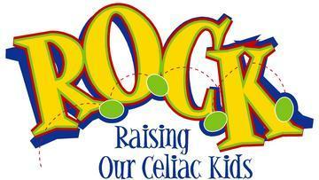

For Our
SPRING EGG HUNT
(Gluten Free Candy-Filled)

Followed by a Gluten Free Pot Luck Lunch
Featuring GF Samples from Epicure Foods Distribution:
Possible samples include The Grainless Baker Products—breads, cookies, muffins, pizzas & other bakery goods; Celiac Specialties donuts; Contes Products—Pierogies, Ravioli's, Stuffed Shells, Lasagna, Manicotti, Spaghetti & Meatballs

Saturday, April 5th, 2008
10:30 am – 1:30 pm
Owen Brown Community Center
6800 North Cradlerock Way, Columbia MD 21045
[location is just minutes from I-95, Rt. 29, Rt. 32]

Pre-registration requested to ensure we have enough eggs hidden for child’s each age group & enough food samples
Linda 410-290-5224 or hickman68@verizon.net

Free Will Donations requested to help cover expenses of renting the site and egg hunt

